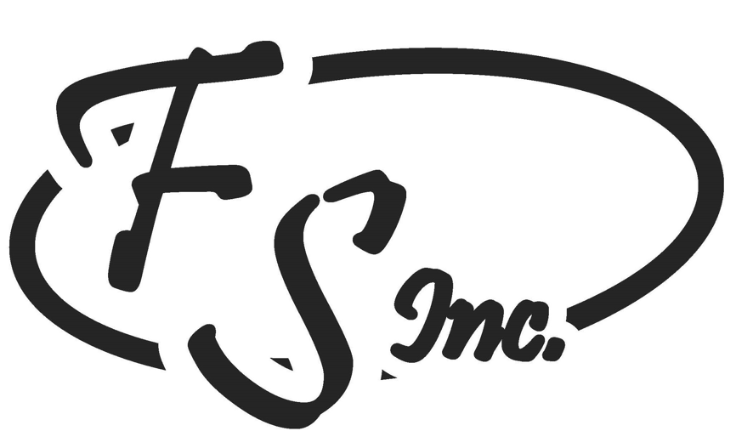

Explanation of FS, Inc. Benefits
Probationary Period for New Employees= 90 Days

- Health, Dental, and Vision insurance (Wellmark Blue Cross Blue Shield)
Available on the first day of the month after 60 days of employment. Payment for insurance starts after 30 days of employment. FS, Inc. pays ½ of employee’s premium

- Life insurance (Kansas City Life) Available after 30 days of employment. No cost to the employee, you must return the application provided in your new hire packet.

- Aflac Insurance Available after 90 days of employment. Complete the “interest” form and the agent will contact you directly.

- 401(k) Available after 90 days of employment. The company match is dollar for dollar up to 5%.

- Paid Holidays Available after 90 days of employment
Memorial Day Thanksgiving Day
Independence Day Christmas Day
Labor Day New Years Day

